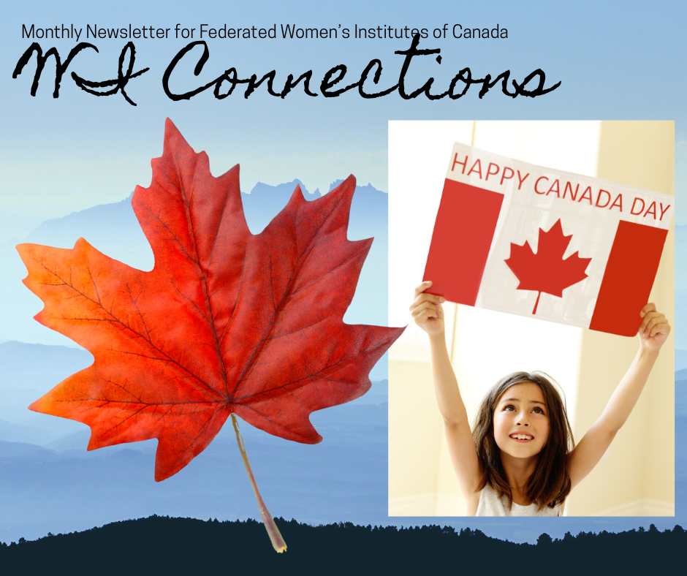
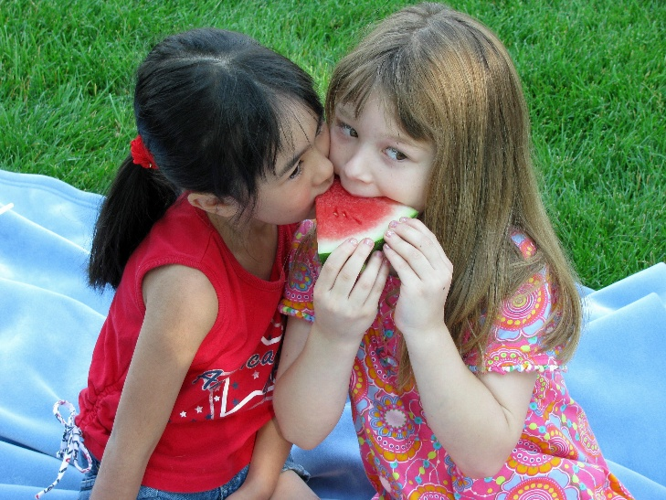
In this issue…
From the President’s Desk…. Page 2
Pen Pal Application Page 7
This n That Page 10
History for you Page 11
ACWW Update Page 12
History of Tea Page 13

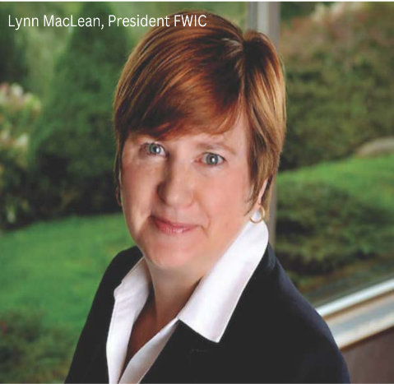
From the President’s desk…

Happy Canada Day! We are so fortunate to live in this beautiful country and enjoy its many benefits. Enjoy the day!
As July arrives, it brings warmer temperatures, a lighter schedule, and an opportunity to spend quality time with family and friends. For those not directly involved in agriculture, it's a perfect time to relax and appreciate the blessings of summer. Our farmers, the vital backbone of our nation, work tirelessly to plant crops and vegetables, harvest hay and silage, to ensure a stable food supply for the upcoming fall season.
Over the past six weeks, I have traveled from coast to coast on behalf of WI. Last month, I shared my experience at the successful Canada Area Convention in British Columbia, as well as the inspiring speakers. Additionally, it was my privilege to represent FWIC and be invited to attend the Prince Edward Island Women’s Institutes (WI) Annual Convention, the Newfoundland and Labrador Women’s Institute Convention, and virtually at the Quebec WI AGM. Conventions and AGMs, whether in-person or virtual, provide excellent opportunities to reconnect with members, establish new connections, and learn something new. The planning committees are to be commended for their superb conventions!
The PEIWI convention adopted the theme “Resilient Together,” with speakers who shared insights on the topic of resilience. Newfoundland and Labrador held its first in-person convention since the COVID-19 pandemic, with the theme “90 Years Strong … Embracing Change,” which was met with great enthusiasm, while Quebec showcased its project of sending postcards to Ukraine, letting them know they were not alone.

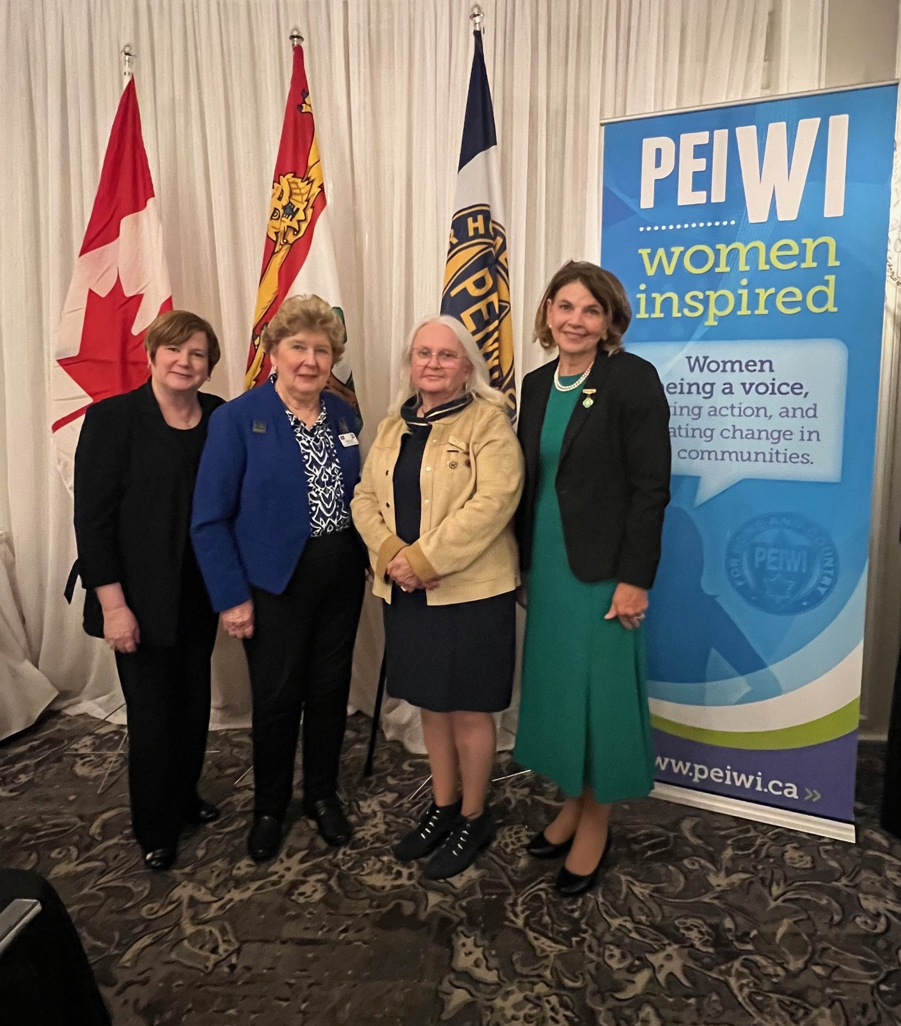
Pictured right: (l-r) FWIC President Lynn MacLean, PEI FWIC Director Miriam Lank, new PEIWI President Carolyn MacFayden, and ACWW Canada Area President Marie Kenny.

Last month also brought an unexpected opportunity. I was honored to learn that FWIC had been invited to participate in a tree planting ceremony in Ottawa at the request of our patron, the Governor General of Canada, Mary Simon. We were not only invited to attend but also assured of priority seating—an honor reserved for only fifty organizations. As many of you may have seen, we were seated at the front, near the ropes, which provided an excellent opportunity to meet King Charles III, Queen Camilla, Prime Minister Carney, and his wife, Diana. It was a true privilege for FWIC to be selected by the Governor General to attend, and for me to serve as a representative of WI. Past FWIC President Margaret Byl and Quebec WI President Linda Janes accompanied me.
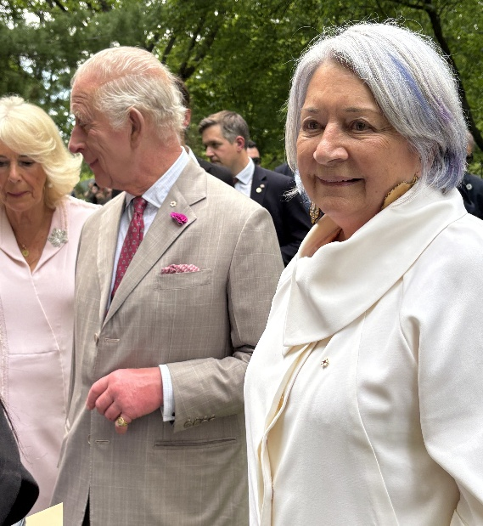
My new line is, “you never know where WI will take you”!
Till next time, Lynn
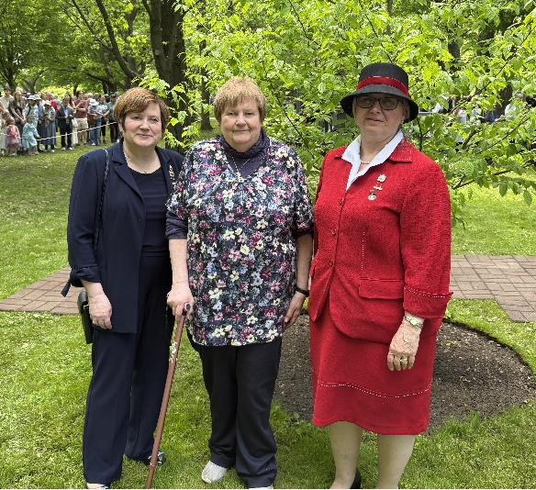

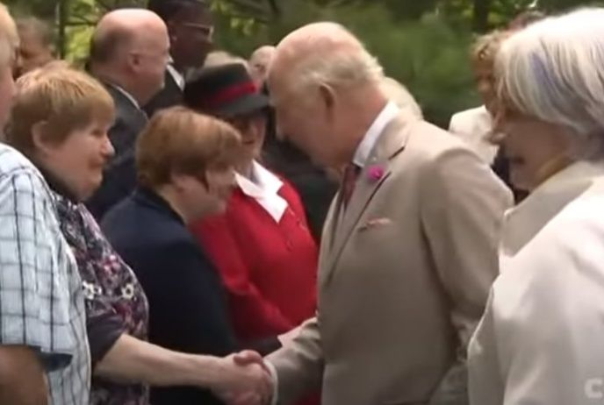

QWI President, Linda Janes, shaking hands with King Charles III at the tree planting ceremony held at Rideau Hall.
Of course, Linda took her moment to chat about the WI.
His mother, Queen Elizabeth II, was a faithful WI member for 80 years. In fact, the women in the Royal family have been faithful members since WI was first established in the UK.
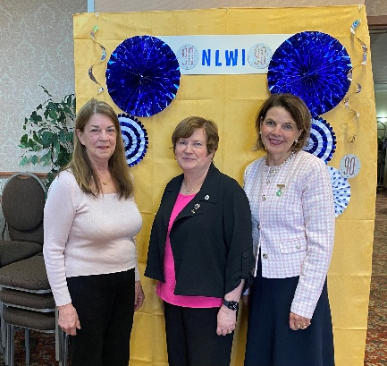

Elizabeth Moss, Newfoundland and Labrador President; Lynn MacLean,
FWIC President, and Marie Kenny, ACWW Canada Area President

WI Connections Contributions
All contributions are welcome.
Please send JPEG and PNG photos, which are ideal, along with Word documents or emailed messages, to wiconnections@fwic.ca. Sorry, PDF documents do not format well. Please avoid formatting such as indenting, formatted numbers, and bulleting. Thank you for your interest in telling about WI in your ‘neck of the woods.’

To contact the FWIC president, please email Lynn MacLean at president@fwic.ca or call her cell at 902-759-4755.
Lynn lives in Nova Scotia.

To contact the president-elect, email Angela at president-elect@fwic.ca, 506-277-6340
Angela lives in New Brunswick.

.

.

Federated Women’s Institutes of Canada
Annual General Meeting

July 8 at 7 pm ET

Federated Women's Institutes of Canada is inviting you to a scheduled Zoom meeting. Please register at registrations@fwic.ca. There is no cost to attend, but donations of $20 or more will receive a charitable receipt. Donations are to be sent to info@fwic.ca (auto deposit)
Topic: FWIC WI Canada AGM
Time: Jul 8, 2025, 07:00 PM Eastern Time (US and Canada)
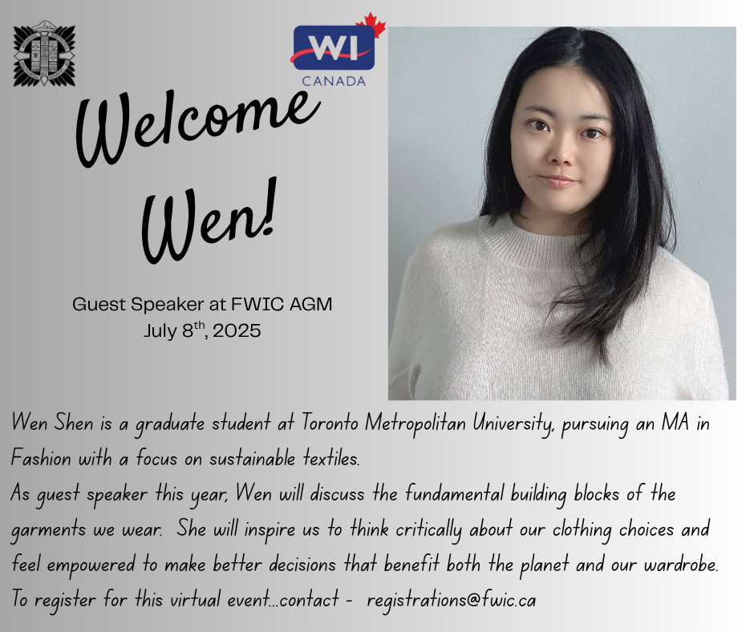
Join Zoom Meeting
https://us06web.zoom.us/j/87146741413?pwd=HBJkrU44mEEkokTt4OH0VGXrS1GUQK.1
Meeting ID: 871 4674 1413
Passcode: 285164


Pen Pals
Several years ago, I saw a notice about pen pals. I love to write, so I signed up. I was matched with a couple of different women in the UK.

I wrote, and they wrote, and then life interrupted. Funny thing is that the organizer, Judy, and I hit it off. And we started to communicate through Facebook. I treasure those communications, it’s been a couple of years, and I finally met her at the FWIC Convention in Nova Scotia.

I still like getting mail, I would like to try the overseas pen pal again, and I AM thrilled with my new friend in Nova Scotia.

So, Judy can you set up a new contact for me …?

Cheers...Judy from BC.

FWIC PAL Programme Registration form
If there are some questions that you prefer to omit for confidentiality, please do so.
Name
WI branch (if applicable)

Email address

Phone number

Postal address

What are your interests? Art, painting, reading, sports, gardening, cooking, etc.

Do you like to travel or are you a homebody?

What age range would you prefer for your pal?

What type of communication do you prefer? (email, Messenger, postal letter, phone, etc.)

What has WI meant to you?

Share about your family (married, etc.)

Which province, state or country would you like to connect with?

Is there anything else you would like to share to help us find a good match?

Please submit your completed form to:
Judy Parks
pals@fwic.ca
(902) 680-0733

Please contact Judy in 2-3 months to report how your pen pal experience works out!
Your registration form will not be shared with anyone else and will be destroyed when you leave the programme.

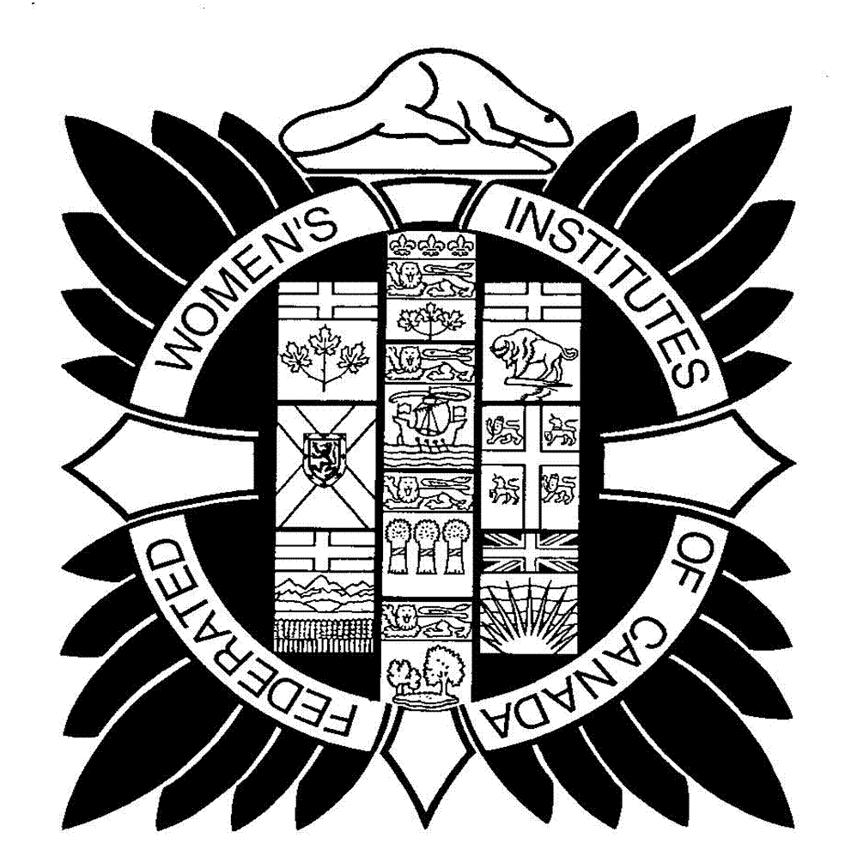
FWIC WI CANADA YOUTUBE CHANNEL
Did you know that FWIC has a YouTube Channel? To access it, open YouTube on any device, and in the search bar, type in FWIC WI Canada. Scroll down until you find the FWIC crest (shown right). Click on the symbol to show the videos we have published.


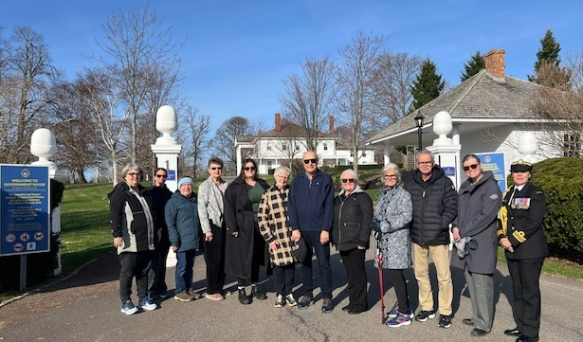
………………………………………………………….

Women Walk the World in Prince Edward Island
L-R: On hand for this year's walk was Kari Ferguson (Treasurer, PEIWI), Angela Birch (Director of Policy, Evaluation and Planning, Department of Agriculture, PEI Government), Mary Hagen (North River WI), Helen Nicholson (ACWW Provincial Coordinator), Lisa MacLean (Confederation WI), Their Honours, the Lieutenant Governor Dr. Wassim Salamoun and Marie Salamoun-Dunne, Carolyn MacFadyen (President Elect), Sheila Gallant (President, PEIWI), Roger Gallant, Dr. Carolyn Sanford (Deputy Minister, Department of Agriculture, PEI Government), and Aide de Camp Michelle F. Hopping (Lieutenant-Commander, Commanding Officer/HMCS Queen Charlottetown/Royal Canadian Navy).

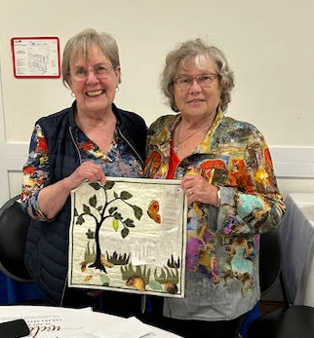
Anne Dunn of Overlander W.I. in BCWI has finally received her third prize award for her article submitted for the FWIC competition in Truro last year. Joan Holthe (FWIC pres. 2018-2021) met up with her at the Canada Area conference in British Columbia earlier this year, enjoying good times with all.

This & That, Submitted by Elizabeth Rushton, Alberta Women’s Institute
Recognition of the Famous Five. 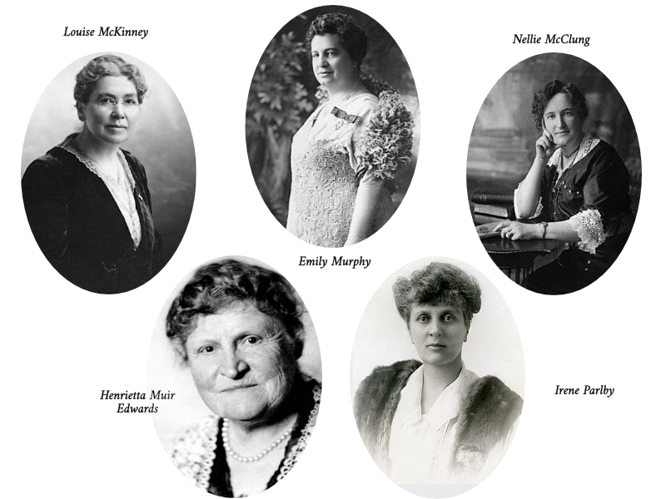

As I researched and wrote about each of the Famous Five and the Persons Case, I wondered if, given how women were largely perceived in society in those days, how I would have felt about their determination to have women declared as persons under the British North America (BNA) Act and have had the same determination and courage to be involved in sending a petition to the Privy Council in England. Would I have signed it if requested to do so? It’s always difficult to answer those questions, as for us in today’s society, where women are accepted in pretty much every area of life, it’s hard to imagine what it was really like ‘back then’.
However, I did some research on two things mentioned in their stories - their being declared Persons of National Historic Significance and being named as Honorary Senators. Persons of National Historic Significance are people designated by the Government as being nationally significant in the history of the country, and as I looked at the long list of those named, I did notice the name of Adelaide Hoodless listed as well as each of the five women.

In October 2009, it is recorded that the Senate of Canada posthumously awarded the title of Honorary Senators during the 40th parliament to five pioneer women known as the Famous Five. The motion was introduced by Conservative Senator Ethel Cochrane of Newfoundland and seconded by Consiglio Di Nino, a Conservative Senator from Ontario. After debate, the motion passed without opposition. This was the first time in the history of the Senate of Canada that the title of Honorary Senator was awarded to anyone. By the way, in case you’re wondering, the person who seconded the motion was a man!
On Parliament Hill in Ottawa, there is a tableau depicting the receipt of the news that, under the BNA Act, women were indeed persons. The Famous Five Foundation in Calgary also has recognized the event with statues of the women located in downtown Calgary and in Edmonton there is a large park named after Emily Murphy and four community parks named after each of the other four women. Unfortunately, the large bronze statue of Emily Murphy at her park was stolen not long ago and parts were later found at a local refinery. It has not been made public how the statue was cut off its base with no one hearing it. I was told it had been placed there by private donors.
Those recognitions had me wondering if there was any acknowledgement of these women where they were born or anywhere else in Canada. I hope to do more research on that soon, but if anyone reading this knows of anything, it would be really interesting to hear about it. If there is nothing, perhaps it could be a local branch or area project to look into something at a local museum or a plaque on the house where she was born? Their maiden names are in each of the articles I wrote about them in previous issues. The places are Chatsworth, Frankville, and Cookstown in Ontario and I will be able to check the other two myself (Montreal and Alix, AB).
However, even if your branch is not located anywhere near these communities or even in Ontario, consider looking into having a display of their accomplishments at your local museum or other suitable location, particularly regarding the Persons Case. That important milestone in the rights of women deserves to be recognized across our country. If you do that, make sure your branch name and WI are included as sponsoring the display – good publicity. Check if the Person's Case is included in your provincial school curriculum, also! And you know what to do if it isn’t!!
…………………………………

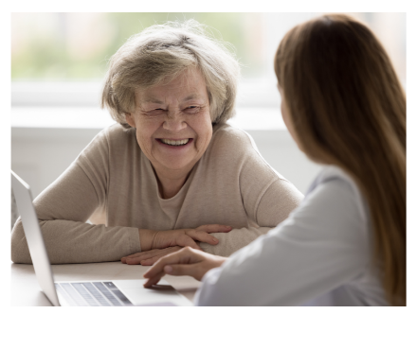
History…What Does It Look Like for You? Submitted by Angela Scott, President-Elect
For me, history feels like a fog. I often get lost in the details — dates, old documents, museum archives. It all seems heavy and hard to relate to. I admit I often want to rush through it, just to find a quick answer. But in doing that, I realize I miss the parts that really matter.
Some people get excited about history, are proud of what they find, and are eager to share. That reaction can feel foreign to me. I don’t always feel that spark. What I do feel is that history is more than old things. It includes failure, silence, missed opportunities, and sometimes regret — and there are important lessons to be learned from these aspects of history. But it also includes moments of strength and community. Those memories, if we let them, can help us figure out what matters now.
Connecting the Dots…
While not idolizing the past, I don’t think we should ignore it either. Things have changed, but maybe not as much as we pretend. Maybe instead of racing ahead, we might look back and borrow what still works. Not for nostalgia’s sake, but because it might actually help.
History shows up in how we live now — in habits we’ve forgotten and skills we’ve let go. Growing and cooking seasonal foods, knowing our neighbours, sharing tools or meals — these were basic ways of living. They made life work, especially in tough times. Today, when so many people are burnt out or disconnected, those old ways might be more relevant than we think.
We’ve been told that progress means moving forward fast. But some of that “progress” came at a cost — less time for people, less patience, fewer practical skills, and plenty of bad habits. The modern world is efficient, but often lonely and overwhelming. It’s time to bring back some of the common-sense practices that once kept us grounded.
What is really working?
I remember working years ago and teaching a ‘new’ craft, making rugs with scrap fabric and a large crochet hook. And I got called out on it…my dear, that’s not new, we made those years ago. My point being…there really isn’t much NEW, instead we see remakes, over and over again. Perhaps history and trying something old again doesn’t mean going backward. It means asking if the way we live now is really working?
…………………………………………………..
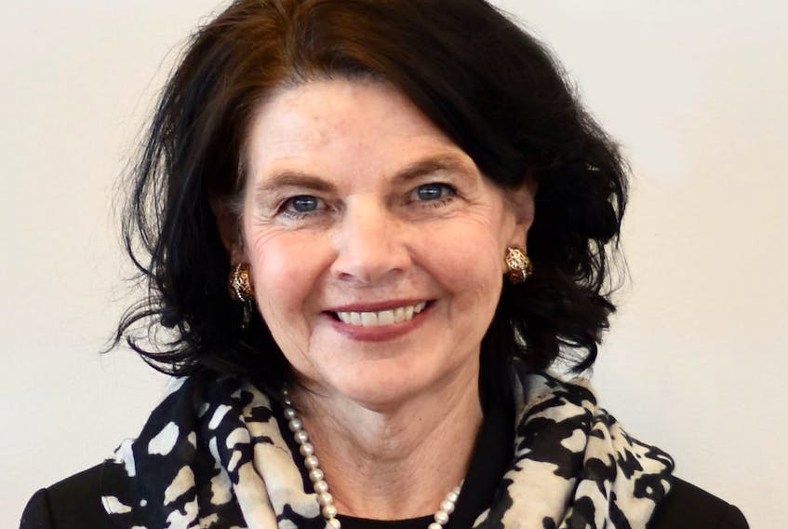
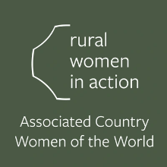
Marie Kenny, ACWW Canada Area President

ACWW Canada Area Update:

Greetings everyone,
I hope this finds you well and ready to begin a wonderful summer in your area of Canada.
My journey as Canada Area President has taken me from Victoria, BC, in May to Gander, Newfoundland, in June. I have been honored to be part of the Twenty-Eighth Provincial Convention of Newfoundland and Labrador Women’s Institutes as they celebrated their 90th Anniversary. The Convention theme, “90 years Strong and Embracing for Change,” was very appropriate, as it spoke to their legacy and their future. Reminding us of all that strength doesn’t come from standing still, but from adapting, evolving, and supporting one another along the way. Newfoundland and Labrador Women’s Institutes have a rich history of tremendous work to enhance the lives of rural women locally, nationally, and globally. Their commitment to educating women, expanding skills, broadening interests, and strengthening the quality of life personally, for their families, and their communities is inspiring. It reminds us all that when women unite with purpose, they not only lift each other up but transform the world around them.
Thank you to President Elizabeth Moss and your hostess committee for an inspiring Convention and for inviting me to be part of your program.
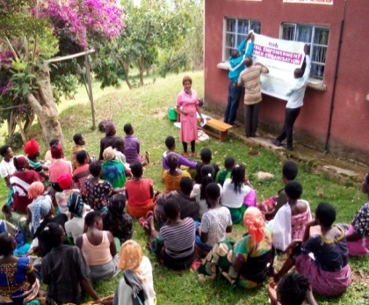
Registration for the ACWW Triennial World Conference in Ottawa, Canada, April 26 to May 1st, 2026, is now open. Early registration ends August 25. Be sure to check the ACWW website for full details and registration information. Registration for the 31st TWC includes the conference package (covering the meeting rooms and all the activities), excursions, gala dinner, and accommodation at the Westin Ottawa Hotel, your meals and refreshments during the conference the activities), excursions, gala dinner and accommodation at the Westin
Just a friendly reminder: when sending WWTW (Women Walk the World) money or donations to the Rural Women in Action Fund, please make cheques out to “The Associated Country Women of the World” with a reference note stating “Rural Women in Action Fund”.
The funding call is now open for the Rural Women’s Health Proposals. Applicants must be members of ACWW. Members must register first to confirm eligibility and to receive the application pack. The application deadline is August 1st, 2025. For more information, you can email projects@acww.org.uk.

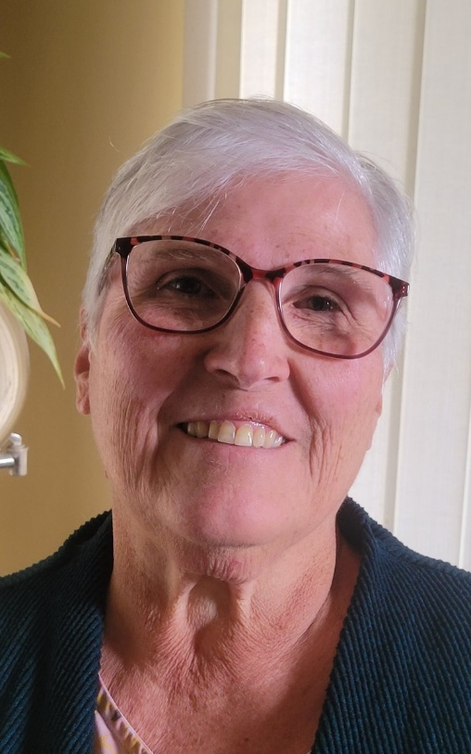
History of Tea – Highlights, Submitted by Susan Hoszouski, BCWI

Tea has a long history in Asia. Drinking tea dates back to the Han Dynasty in China to around 206 BCE. Tea was primarily consumed for medicinal purposes during earlier times and was not really a very popular beverage.

During the Tang Dynasty (618-907 CE), tea became a more common drink and was the beginning of tea-tasting ceremonies and the creation of the first tea compendium. Tea was becoming regarded as having very high importance. Early on, it was understood that drinking herbal teas have many beneficial qualities for the body.

The truly wonderful teas were always reserved for the social elite. In Japan tea was introduced by Buddhist monks in the 9th century CE. The Japanese tea ceremony, known as "chanoyu" or "Sado", was a highly ritualized practice, emphasizing the aesthetics and spiritual aspects of tea drinking. Again, tea drinking was placed in such high regard because our ancestors understood
how much herbal teas can do for the body.

Tea culture has a rich history in many parts of the world. Primarily consumed back then by the upper classes and used in religious ceremonies. Today tea
is served as a symbol of hospitality. Next time you sit down and enjoy your favorite cup of tea, remember you are embracing centuries of wisdom, history and the best nature has to offer in every cup!!

As I sit and have a cup of tea, I remember my time in Malaysia and our trip to the Cameron Highlands Tea Plantations, the scenery, and the splendid rows upon rows of tea leaf bushes. My interest in writing this article also stems from the fact that my WI Branch just recently hosted our 3rd Annual High Tea fundraising afternoon. It has become an event that is highly anticipated and looked forward to each year. The event requires tons of preparation and work, but it is well worth the effort.

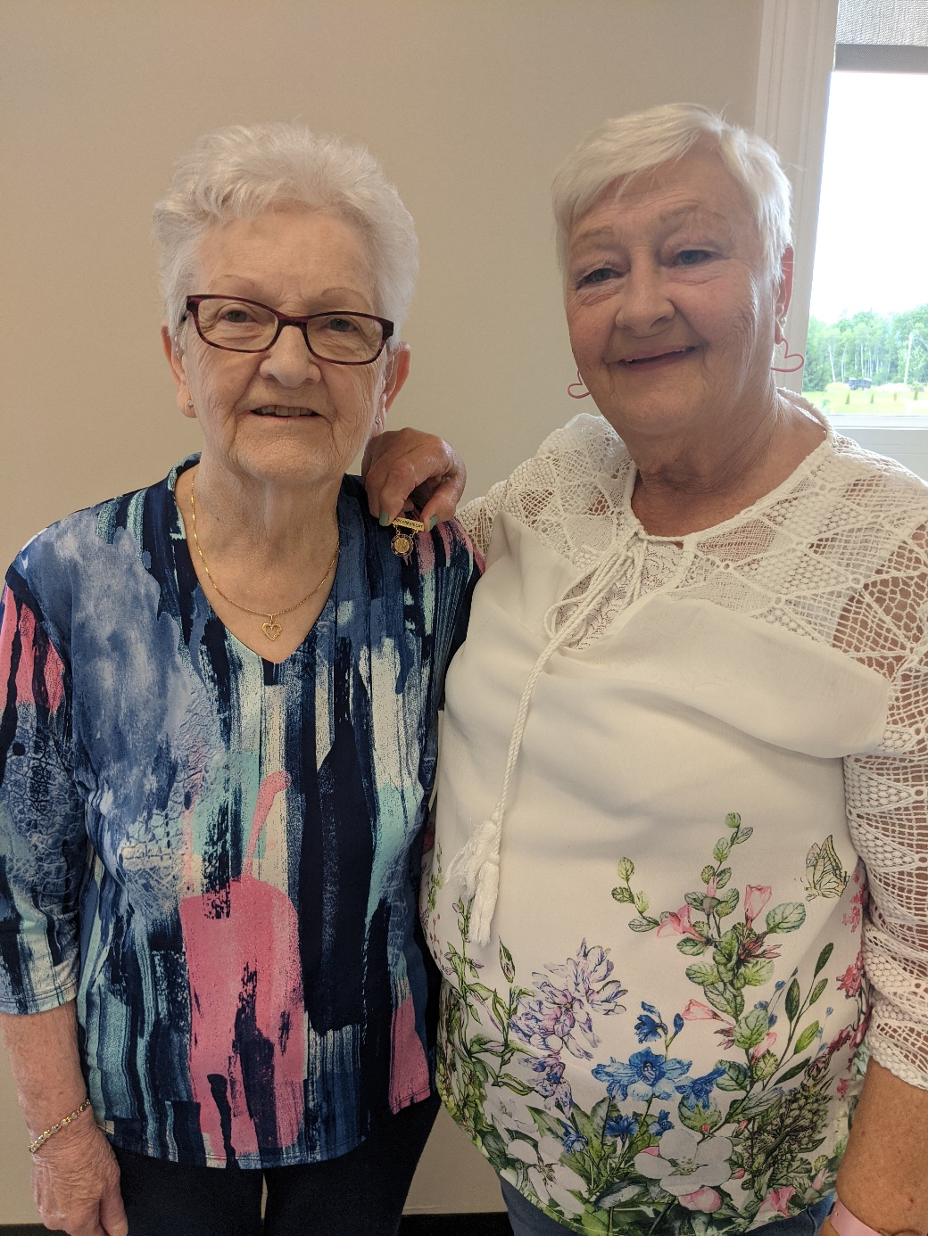

Welcome, New Brunswick Women’s Institute President Madine Keenan, shown here getting ‘pinned’ by
Past-President Sharron Adams. Congratulations Madine!
……………………………….
Staples Canada
Preferred members just need to sign up at their local Staples store or Staples online to register their organization.
This is what is offered when you become a preferred member:
250 Business Cards for free
100 Postcards for free
10% off Copy Printing
30 to 60 days return policy, if not satisfied with the purchase

~ Margie ~ Margaret Taylor, WINS President

Adelaide Hunter Hoodless Homestead, 359 Blue Lake Rd. St. George
Invites you to join us for our May – Sept 2025 Schedule of Events
DATE/TIME | EVENT | WHAT TO EXPECT | COST
Sat May 10th | Doors Open (along the grand) | Come check us out. | Free admission
Sunday May 18th  2:00 – 4:00 pm | Voices from the Past – Narrated by professional storytellers | Bringing recognition and awareness of influential women from our past | Free will donation
Saturday May 24th  1:00 – 3:00 pm | “Grandma Gwen Drives a School Bus” Official Book Launch | Join us to celebrate the release of Gwen Dawson Hunter’s book. Hear from her literary mentor Dr. Michael Williams, listen to excerpts, purchase a book, have it signed, and enjoy refreshments & delicious treats | Free will donation. Text (905) 802-8498 to register.
Saturday June 7th  9:30am  (Runs each Saturday until end of August) | Saturday morning yoga with Tracey Graham  (back by popular demand) | Bring your yoga gear and enjoy a rejuvenating outdoor yoga session in the pavilion. | $10.00 admission at the door
Thursday June 12th  6:30-8:00 pm | Avenue of Music Concert at the AHHH Pavilion | Bring your lawn chair, enjoy the sounds of local musicians, and jump on stage to belt your favorite karaoke tunes! | Free will donation  Hot dogs and drinks are available for purchase
Saturday, June 14th  2:00 – 4:00 pm | “Evelyn: Did She or Didn’t She?”  Come hear the story of Evelyn Dick | Author Sarah Farr tells the story of a Hamilton socialite accused of the murder of her husband and son in one of the most sensationalized murder mysteries of the 1940s | Free will donation  Refreshments and treats included  Register at info@adelaidehoodless.ca
Friday, June 27^{th,} 10:30 am - noon | Mindset Matters: A positive psychology women’s discussion group | Nancy leads a women’s folk discussion on positive psychology topics – this month’s topic is resilience. | $25.00 includes session and refreshments.  Text 905 802 8498 or email info@adelaidehoodless.ca
Trillium seed grant acknowledgement ceremony | Preceding the opening performance of Skater, we will pause to thank provincial officials. | The Arts program, which includes the SKATER play, is funded by a Provincial Trillium Seed Grant. | Please come and acknowledge with us the grants that allow us to keep heritage history and arts accessible in our community.
Friday, July 4th 7:00 pm  Saturday, July 5th 7:00pm  Sunday, July 6th 2:00pm | Opening weekend performance of “Skater”, a play inspired by Adelaide’s life. | Playwright Vincent Ball, Artistic Director Peter Muir, and the AHH Homestead present “Skater”. A theatrical production inspired by the life and achievements of Adelaide H. Hoodless. | Free will donation  Register at info@adelaidehoodless.ca
Friday, July 11th at 7:00 pm  Saturday, July 12th at 7:00 pm  Sunday July 13th 2:00pm ** | Closing weekend performance of “Skater”, a play inspired by Adelaide’s life. | Playwright Vincent Ball, Artistic Director Peter Muir, and the AHH Homestead present “Skater”. A theatrical production inspired by the life and achievements of Adelaide H. Hoodless. | Free will donation  Register at info@adelaidehoodless.ca  ** Our closing show on Sunday, July 13^{th,} will be held in front of the St. George Mural at 48 Main St. South, St. George
Thursday, July 17th  6:30 – 9:00 pm | Avenue of Music Concert at the AHHH Pavilion | Bring your lawn chair, enjoy the sounds of local musicians, and jump on stage to belt your favorite karaoke tunes! | Free will donation  Hot dogs and drinks are available for purchase
Mon July 14th – Fri 18th  Drop off @ 10:00am  Pick up @ 4:00pm | Kids Pioneer Day Camp  For kids ages 6 - 10 | Give your kids an unforgettable week at the homestead, complete with pioneer games and crafts, outdoor activities, and guest instructors in nature, theater, and music. Learn about local history, how bees make honey, and what life was like for children in the 1800’s | $200.00 per child, per week of camp  Light snacks and refreshments provided. Pack your own lunch.  Registration is available through Eventbrite or the Homestead.

